Revolutionizing Real-Time Sign Language Recognition Through Advanced Deep Learning

Introduction
This pioneering research introduces an AI-powered web application designed for real-time, continuous sign language translation. By leveraging cutting-edge neural networks and hybrid data sources, this system aims to break communication barriers for the deaf and hard-of-hearing communities. The research has been validated using the Sign Language MNIST dataset.
American Sign Language (ASL) is an essential communication medium for the deaf community in North America. Although primarily used by individuals with hearing or speech impairments, ASL and similar signs can be leveraged in Natural User Interface (NUI) systems for human-computer or robot interactions through hand gestures. The automatic recognition of ASL using various sensing devices has been studied extensively, with significant progress made over the decades.
Two primary categories of sensing devices are used for ASL recognition: wearable devices and non-wearable or marker less vision-based devices. Wearable devices, such as cyber gloves embedded with flex sensors or Inertial Measurement Unit (IMU) sensors, directly sense hand status, including joint angles, spatial positions, and movements, offering precise information. However, they are often heavy and uncomfortable for daily use. In contrast, marker less vision-based recognition has grown in popularity due to advancements in affordable vision and depth cameras, such as Microsoft Kinect. These devices do not require sensors to be attached to the human body but present challenges due to the complexities of ASL signs, high interclass similarities, large interclass variations, and constant finger occlusions.
This research focuses on recognizing the ASL alphabet. The task of ASL alphabet recognition generally involves feature extraction and subsequent multiclass classification. Various methods have been explored to extract discriminative features and build powerful classifiers. For instance, Pugeault and Bowden applied Gabor filters to both color and depth images, achieving a 49% recognition rate, though the system failed to capture enough discriminative information. Wang et al. proposed a Superpixel Earth Mover’s Distance (SP-EMD) metric, achieving a 75.8% recognition rate. Recent studies have also explored 3D depth information, such as Kuznetsova’s Ensemble of Shape Function (ESF) descriptor and Zhang’s Histogram of 3D Facets (H3DF), which leveraged multi-layered random forests and SVM classifiers, respectively.
Deep learning approaches, including CNNs and RNNs, have shown extraordinary performance in classification tasks, including ASL recognition. Unlike traditional handcrafted feature extraction methods, deep learning models automatically capture the most discriminative features from real data. For instance, Ameen and Vadera introduced a CNN model for ASL alphabet recognition that processed both color and depth inputs, reporting an accuracy of 80.34%. This research builds on these advancements, integrating CNNs and hybrid optimization strategies to enhance the accuracy and efficiency of real-time ASL recognition.

Identified Problem
The global challenge of hearing impairment is significant, with over 466 million individual’s worldwide experiencing disabling hearing loss, according to the World Health Organization (WHO). In the U.S., about 15% of the population faces hearing impairment, leading to social isolation, reduced educational opportunities, and higher unemployment rates. Existing sign language translation systems have several shortcomings. They excel in isolated sign recognition but struggle in continuous scenarios, with accuracy dropping below 90%. Common datasets like PHOENIX14T cover specific sign languages, neglecting many regional dialects. Vision-based systems face challenges with lighting and background noise, while sensor-based systems are often cumbersome. Sensor-based acquisition technologies, including digital gloves and Myo armbands, provide robust alternatives by tracking precise hand movements. Furthermore, most systems focus only on static signs without supporting fluid, continuous interactions.

Why Innovation is needed?
A hybrid deep learning approach, combining vision-based (RGB and depth) data with sensor inputs, offers a promising solution. This system bridges the gap between static and continuous sign recognition, providing a scalable and user-friendly platform validated by the Sign Language MNIST dataset.

Research Question
This research seeks to explore how advanced deep learning techniques and hybrid data inputs can be integrated to develop a real-time, accurate, and interactive sign language recognition system that performs robustly across diverse environments.

Background Research
In recent years, there have been ongoing efforts to develop automated methods for the completion of numerous linguistic tasks using advanced algorithms that can ‘learn’ based on past experience. Sign language recognition (SLR) is an area where automation can provide tangible benefits and improve the quality of life for a significant number of people who rely on sign language to communicate on a daily basis. The successful introduction of such capabilities would allow for the creation of a wide array of specialized services, but it is paramount that automated SLR tools are sufficiently accurate to avoid creating confusing or dysfunctional responses. In this section, we provide a brief background regardng some important approaches that have been utilized for automated SLR.
- MACHINE LEARNING (ML) :
The machine learning concept encompasses a number of stochastic procedures that can be used to predict the value of a certain parameter based on similar examples that the algorithm was previously exposed to. A simple example, illustrated by Algorithm 1, shows how a general formalization of the learning process takes place. There are many different methodologies that belong to this group; some of the best-known methods include naïve Bayes, random forest, K-nearest neighbor, logistic regression, and the support vector machine [33], [35]. All of these methods undergo a training phase, which can be either supervised (using labeled input data) or unsupervised (without labeled data), and use input features to establish connections among variables and acquire predictive power. However, owing to their simplicity, such methods have limitations when there is a need to capture nuanced semantic hints, as is the case with most linguistic tasks. On the other hand, they can often provide the foundation for the development of more powerful analytic tools and serve as a measuring stick to evaluate progress.
Algorithm 1 Learning Process

Input: x, is a d dimensional vector of features
Output: y, is the output decision
1: Target function f : X ⇒ Y the ideal formula (Unknown)
2: Data: (x₁, y₁), (x₂, y₂), . . . , (x_{N} , y_{N} ) training examples
3: Hypothesis g : X ⇒ Y formula to be used
4: Learning algorithm g ≈ f final hypothesis

Machine learning techniques are used to aid in sign language recognition and have achieved some degree of success. Some of the earliest studies in this field were based on data input from wearable sensors, which provide a very direct translation of a user’s movements. The data can be filtered using techniques such as SVM to provide a reasonably accurate recognition of the intended sign. Some of the aforementioned machine learning methods are used primarily to analyze static content (i.e., individual signs isolated in time and space), while in some cases, there have been attempts to interpret continuous segments of sign language speech, necessitating the use of dynamic models such as dynamic time warping or relevance vector machines. In general, basic stochastic models are better suited for simple SLR tasks, which is why they were extensively used in the early stages of research. These statistical models typically require less computing power than more complex architectures, although this depends on the number of analyzed features as well as the size of the dataset. As more complex ASLR applications naturally require the inclusion of additional variables and sometimes additional modalities, the simplicity of basic models remains attractive. Thus, simpler machine learning methods remain valuable tools and often serve as comparison benchmarks that can be used to evaluate the properties of newly proposed methods.
- DEEP LEARNING:
Recently, basic machine learning approaches have been largely replaced with deeper architectures that employ several layers and pass information in vector format between layers, gradually refining the estimation until positive recognition is achieved. Such algorithms are usually described as ‘‘deep learning’’ systems or deep neural networks, and they operate on principles similar to the machine learning strategies described above, although with far greater complexity. Based on the structure of the network, two architectures are commonly used for a number of different tasks: recurrent neural networks (RNNs) that include at least one recurrent layer, and convolutional neural networks (CNNs) that include at least one convolutional layer. Depending on the number and type of layers, these networks can exhibit different properties and are generally suitable for different types of tasks, while the training phase decisively impacts the performance of the algorithm. The general rule is that larger and more specific datasets allow for more robust network training, and therefore the quality of the training set is an important factor. Additional fine-tuning of a model can usually be achieved by changing some of the relevant hyper-parameters that define the training procedure [36]. The majority of research involving the automation of SLR tasks is currently based on methods that rely on a combination of images and depth data, which generate a tremendous amount of information that often requires analysis in real time (or at least taking the temporal dimension into account). With larger and more diverse datasets, simple machine learning methods tend to underperform, which is why many of the more sophisticated models are based either on RNN or CNN design. Deep networks can be trained using multimodal input (e.g., skeletal data combined with depth image from Microsoft Kinect), and in some applications, they can achieve a recognition accuracy of over 98% under optimal conditions. The advantages of deep learning were demonstrated by Konstantinos’s et al. [37], who successfully used data from disparate sources to identify sign language words in isolated form, although their model displayed uneven performance depending on the dataset used. More demanding SLR tasks, such as interpretation of continuous speech or real-time translation, require even more sophisticated models, which in some cases require an increased number of layers (depth). While deep models appear to be a safe choice for the role of empowering automated SLR applications in the future, it remains to be seen whether the current architectures will survive in their present form or will evolve into new models that can ‘understand’ the semantic aspects of sign communication more astutely. Possible models that could be more widely used in the future include deep belief networks with a very large number of layers, as well as networks based on auto encoders.
REVIEW METHOD
In this study, we summarize and organize scientific data about the subject of Sign Language Recognition (SLR) for the benefit of the entire research community. In order to assist anyone interested in the fundamental knowledge in this field, we complemented the basic facts about each study with an impartial assessment of its quality and potential for positive contributions. We attempt to answer the following main research questions:
Question 1 – Which studies have been conducted address- ing automated Sign Language Recognition, and what are the available datasets?
Question 2– What techniques in Automatic Sign Language Recognition for various languages are applied to date?
Question 3 – Which challenges remain unsolved in this scientific field?
One of the ultimate objectives of this paper is to lay the groundwork for future inquiries about SLR and clarify any ambiguous elements that might confuse some researchers. We accomplished this in three phases – preparatory, execution and presentation, with each stage including several steps. These steps included 1) selecting the most relevant research questions, 2) setting fundamental rules for the evaluation procedure, 3) formalizing the selection threshold, 4) assessing the quality of the work’s premises and results, 4) looking into the methodological setup of the experiments, and 5) extracting any bits of information that contribute to answering the central questions.
REVIEW PROTOCOL
We followed a defined procedure during the literature review, allowing for a more objective evaluation of the paper content. This procedure consisted of numerous tasks, starting with selecting relevant variables, isolating the authors’ strategic approaches, analyzing the methods and techniques used to obtain the results, sorting out quantitative output, and defining the principles for generalization and summarization.

- INCLUSION AND EXCLUSION CRITERIA
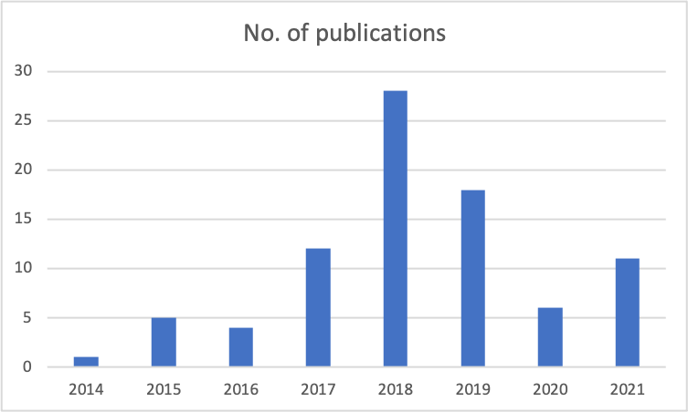
During the collection of scientific works, a set of well-defined parameters were used to decide which works to include. Since the subject of this paper is SLR, only papers from this field were taken into consideration. The period covered is between 2014 and 2021, as shown in Fig 1, as the idea was to provide a systematization of contemporary research.
FIGURE 1. Number of publications on sign language recognition by year.
- SEARCH STRATEGY
Finding the most relevant research material required an ardu- ous process combing publicly available sources using a com- bination of automated tools and human workforce. Specific keywords drove the automated segment, which are displayed in Table 2.
This collection of studies is continually expanded through addition of individual papers that match the same level of relevance as those found by the algorithm. We included all of the most significant online repositories of scientific content in the search, from Google Scholar, MDPI, Springer, Elsevier, and IEEE explore to ACM and ArXiv. The proportion of papers from each source is shown in Fig 2.
The overall objective at this stage was to discover as many works that address the topic of SLR as possible. After completing this stage, we carefully analyzed the entire corpus of collected material using the forward/back technique. This allowed for a more detailed understanding of each paper, with the ability to track all references and follow the significant lines of research. In this way, it was possible to ensure that no foundational studies are missing from the study and that the final collection of SLR papers is truly representative of the most successful research directions. We then processed the collection based on the Mendeley method, which made it possible to easily identify and remove identical items from the list, making the content more readily searchable. We noted several trends in this part of the process, which included a
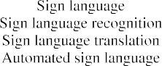 | 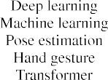
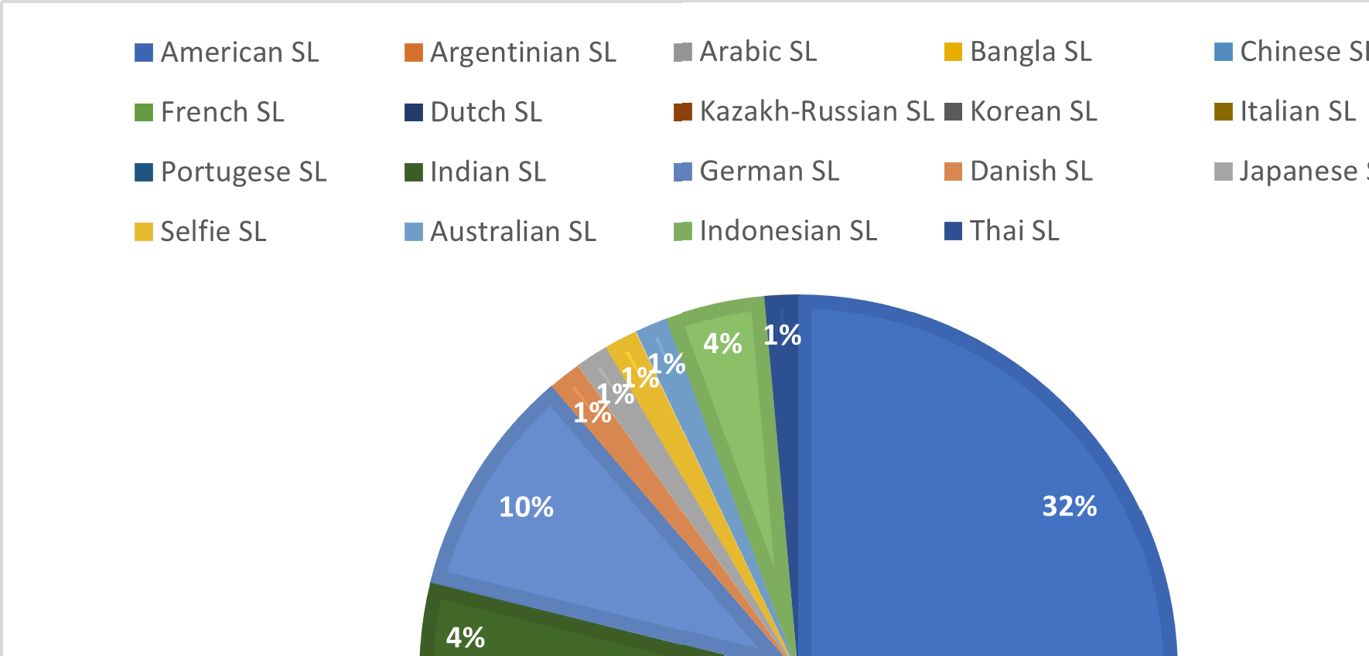


TABLE 2. Keywords for searching stage

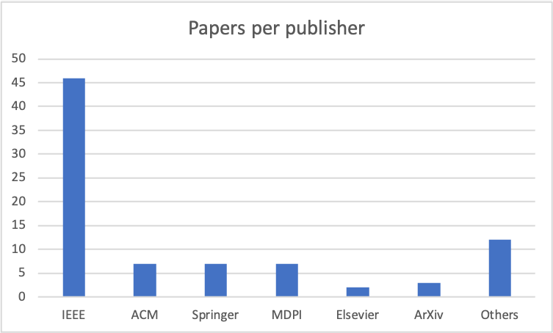
FIGURE 3. Number of publications on sign language recognition by language.
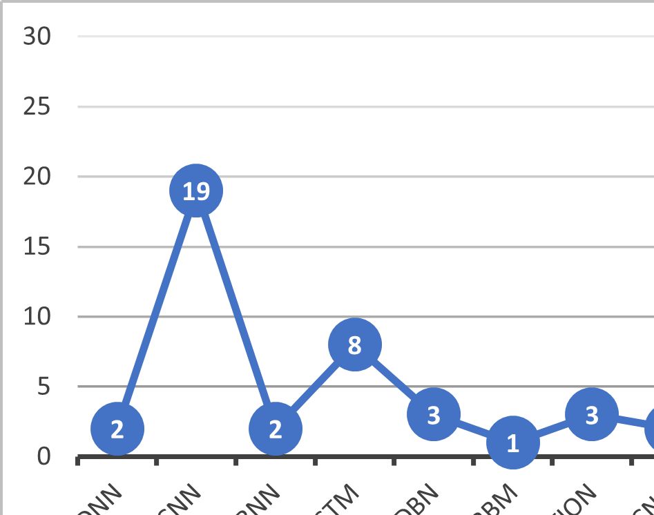
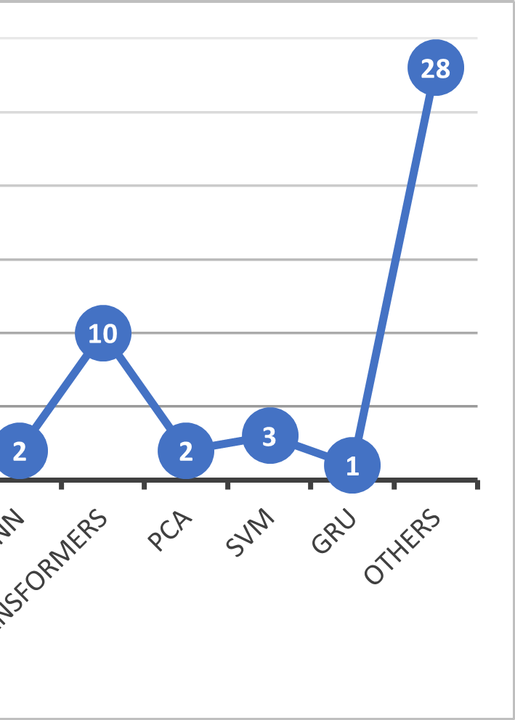
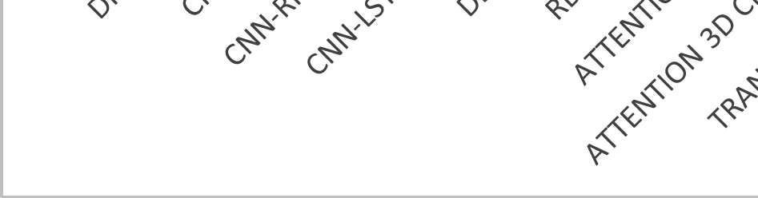
FIGURE 2. Number of publications on sign language recognition by publisher.

FIGURE 4. Number of publications on sign language recognition by architecture\
Breakdown of collected works based on the local variation of sign language they refer to. A majority of works in the collection (more than 30%) were related to the American variation, but French, Argentinian, Arabic, and many other SL variations are also represented, as seen in Fig. 3.
Another factor that was used to differentiate between papers is the type of architecture of the proposed solution. Full overview is available in Fig. 4.

STUDY SELECTION PROCESS

During the initial search, we found 196 different papers, although 11 of them were duplicates that we immediately disqualified. All original papers were reviewed using the principles outlined in Table1 and information available on the first page of the paper. In this manner, we removed all works not connected to the research field, collected from unreliable sources, or with other weaknesses. Examination of this kind identified 47 entries that did not meet the inclusion criteria; 138 core and relevant studies remained.

We examined the full text of the studies next, and removed any that failed to directly address SLR or to support their hypothesis with high-quality data removed as well. Next, we took the quality of all quotes and correct naming of sources into account, and performed online checks to ascertain the authorship of source papers. In the last phase, we per- formed a qualitative evaluation to determine which studies deserved to be reported on. The entire selection procedure cut down the number of included works to 5.

Key References
- Deep Learning for Sign Language Recognition: Current Techniques, Benchmarks, and Open Issue.
- Recent Advances on Deep Learning for Sign Language Recognition.
- Sign Language Recognition Using Modified Deep Learning Network and Hybrid Optimization.
- Enhancing sign language recognition using CNN and SIFT: A case study on Pakistan sign language
- Technological solutions for sign language recognition: a scoping review of research trends, challenges, and opportunities
Importance of Hand Gesture for SLR
Because of the importance of hand gestures for SLR, and given the significant amount of scientific research that has been carried out in this field, we limit our review to the most important points while mentioning the most important studies. Gesture interpretation has been a subject of scientific research for several decades; consequently, numerous reviews of this field have been conducted at various points in time. One of the earliest reviews was performed by Gavrila [143], who considered several 2D and 3D models for the analysis of human motion. Moeslund and Granum [144] provided a comprehensive recapitulation of two decades of research involving gesture tracking and recognition, while Ribeiro and Gonzaga [145] focused primarily on real-time approaches available at the time. Some of the more recent publications include an updated review of opportunities and challenges in this field undertaken by Rautaray and Agrawal [146]. Kumar and Bhatia [147] discussed various feature extraction techniques, while Mohandes et al. [148] presented a survey of sensor-based and direct measurement methods for sign language recognition. Because this field has experienced sig- nificant progress and undergone many reviews over the past two decades, we provide a brief overview of the current state of research in the field of hand gesture and sign language recognition by automated systems.
A majority of sign language characters and words can be expressed with simple hand gestures, which makes correct recognition of hand shapes a very practical feature for auto- mated systems. However, the process of recognizing hand gestures involves many difficulties, which may be related to different hand sizes and shapes among signers, as well as different skin shades. In addition, various individuals may use unique styles to display certain elements when signing. Such difficulties can be resolved through the use of advanced analytic techniques aimed at identifying patterns independent of the signer’s identity or the physical properties of their hands.
Because deep learning networks have the capability to identify latent connections among many different variables, they can be effectively used to analyze hand gestures in ASLR. Depending on the regional variations of sign languages, both one-handed and two-handed gestures can be used to express certain words or phrases, with single-handed signs usually assigned basic meanings, such as letters or numbers. Thus, hand gesture analysis alone has the potential to correctly recognize simple linguistic content from still images or videos, as well as other sources. In other applications, hand gesture analysis may be complemented by other techniques, such as tracking head movements. Given that hand motion is the central building block of all sign language communication systems, this aspect of SLR is unlikely to lose relevance despite increased focus on full- body tracking and continuous sign language interpretation. However, pure hand gesture analysis techniques are likely to be combined with other methods to obtain the best results. This is exemplified by the increasing number of hybrid models that consider many different elements of a signer’s behavior.
USING POSE ESTIMATION FOR SLR
Because body configuration plays an important role in sign language recognition, pose estimation techniques are among the core tools in this area. The basic idea is to determine the exact pose of the entire body based on the positions of certain fixed points that can be ascertained through measurement. While this can be accomplished in various ways, deep learning algorithms have proven effective in this task given sufficient training using well-chosen samples. This is especially true when high-quality input is provided, preferably from more than one source/modality.
  - POSE ESTIMATION BASED ON RGB IMAGES
A method using a convolutional neural network was sug- gested by [154] for determining pose of the human body by analyzing pictures of variable size, thus comparing how individual body parts are spatially organized. The final pre- diction required the operations of pooling and up-sampling to be repeated in several iterations. When this model was experimentally tested with two different datasets, it accomplished excellent results that outperformed the baselines for approximately 1.7-2.4%.
Another model using the same type of neural network was presented by [155], and it leveraged mutually dependent variables to predict the body position. In addition to a CNN network, this method also includes already prepared knowledge maps, and it employs a procedure that doesn’t have to create a graphical representation in order to produce accurate output. This was confirmed by empirical testing where the so called Convolutional Pose Machine method outperformed all alternatives by 9% on the MPII set, 6% on the LSP dataset, and 3% on FLIC.
A model with cascading architecture was constructed by [156] in 2014, using DNN as the basic tool for estimating the positions of joints on the body and their mutual relations. This model frames the problem as a matter of regression, which turned out to be a very suitable paradigm, as evidenced by the performance of the model which was above the marks set by earlier solutions by 2% and 17% on two commonly used datasets. In the work of [157], a new dataset for SLR research was presented along with a benchmark for body position predictions for the comparison of techniques for pose estimation based on deep learning. Interestingly, they studied the possibilities for transfer learning and found evidence that this phenomenon applies in the field of SLR [158].
A similar model for pose estimation that uses RGB photos and deep learning was suggested by [159], starting from the linear SMPL model. In this work, three-dimensional representations of body joints were deployed as intermediaries and a regression of parameters was performed. The model relies on auto encoders to act as the link between the regressed SMPL and a convolutional neural network, guaranteeing that any structural imperfections would be corrected. Those improvements yielded a tangible performance boost in comparison with the basic SMPL on Surreal and Human 3.6M sets.
Sign language communication relies on more than one channel, and in addition to hand movements, facial expressions and body postures are commonly used to express meaning. While much work has been performed in the area of automatic recognition of hand gestures, the literature concerning the analysis of body positions is not as abundant. Jain et al. [160] attempted to address this problem by analyzing the relationships among various body parts using a CNN. On the other hand, Yang and Ramanan [30] organized the data in tree-like fashion and used an SVM as the classifier.
Another notable study in this area was conducted by Chen and Yuille [161], who used a graphical model to rep- resent the spatial configuration of body joints. This approach was improved by Charles [162], who extracted temporal information from successive images to improve the capability of the system to interpret body positions, while Toshev and Szegedy [156] provided an alternative method for body joint position evaluation. Although there are many competing principles and ideas, the latter two approaches were chosen by the authors of this study as the starting points for conducting experiments on a new dataset, with the objective of establishing the most optimal methodology for body posture detection. One more recent solution based on a convolutional network for analyzing graphs was proposed by [163], where a human body is presented in three dimensions by multiple points and links between them. This model deploys an attention mechanism to discriminate between data and contextualize this schematic representation. According to the results of experimental testing, this model can bring some modest gains in the range between 0.7% and 3.4% compared to alternative methods on various SLR datasets.

  - POSE ESTIMATION BASED ON DEPTH IMAGING
A model formulated by [164] combines components of convolutional and recurring neural networks with a self- correcting feature that can improve previous predictions. This model builds a 3D vector space constructed from local data and extracts partial body poses from it while accounting for the noise. The authors tested the model on an original dataset and found that it is indeed superior to any of the existing alternatives. Depth imaging also has a central role in the solution suggested by [165], which is named Depth Ranking Pose Estimation for 3D images. In this concept, CNN network is used for deciding between candidate pairs in the initial phase, followed by another step in which 3D pose estimations are made, thus combining depth data with two-dimensional images to great effect. This model was evaluated using the standard Human 3.6M dataset, yielding a significant accuracy improvement on the scale of over 6 mm over any competing 3D pose estimation methods.
A model named DDP or Deep Depth Pose was proposed by [166], where body positions were approximated by the construction of maps based on depth information. Such maps were created in advance and contained many different body positions along with all relevant joints. This approach was practically proven to be effective, outperforming the bench- marks by more than 11%.
  - ANALYSIS OF VARIOUS POSE ESTIMATION MODELS
Since body position estimation has an important role in many different fields of research including SLR, there have been many attempts to formulate a successful model based on deep learning networks of convolutional and recurrent types. Introducing three-dimensional imaging and construction of depth maps has greatly increased the recognition capacity of such models. Some of the techniques aimed at achieving further gains in terms of accuracy comprise cascade or tree-like structures, imposing of certain limits, etc. From experimental evaluations, it is clear that recent models are far more powerful and reliable than their predecessors, but even the most complex solutions are still far from universal applicability [82].
Research directed towards better interpretation of body positions remains a central topic for scientific research. In particular, researchers are working to ensure that exact positions of each joint can be determined even when ambient noise is present in the images or parts of the body are blocked from view. There has been a lot of progress with 3D mapping of the body positions, but a part of the complication arises from the fact that multiple 3D positions can correspond to a single 2D pose. An additional complication is caused by the difficulty of labeling 3D joint images, necessitating the use of technologically advanced input devices. On the other hand, effective regression of 3D information requires highly precise mapping of spatial relations between key body points. Many existing models track multiple aspects including precise location of every joint in three dimension, from various angles and with regard to specific body shapes. Such models represent the foundation for future SLR research that new methods can build upon. Technological advancement of capturing devices also contributes to improved pose recognition and shape prediction abilities of new systems. Fusion of different types of data (i.e. thermal imaging or hybrid data) with vision-based indicators can make the systems more reliable under real life conditions and thus represents a promising direction of research.
Using sensor technology, the positions of the key points (i.e., limbs and joints) are transferred directly, whereas in image-based methods, those positions are inferred based on 2D images. Because of this essential difference, the methods chosen for completion of this task must reflect the type of input as well as the intended outcome [167]. Deducing the pose is instrumental in correcting the interpretation of the content of sign language communication [152]. This aspect is particularly important for continuous SLR, where individual signs are displayed in a non-stop stream, and changes in body position can be indicative of the intended meaning of the entire expression.
Many factors can affect the performance of pose estimation algorithms, from the choice of features that can include both 2D and 3D data points, to the classifier depth and architecture. Many of the latest tools for pose estimation achieve relatively high accuracy, but they are too prone to false recognition to consider them suitable for immediate practical application on a mass level [168]. In recent studies, there has been a tendency to use advanced technology, including the Microsoft Kinect device, to detect body poses based on multiple parameters, which is clearly a direction that will be exploited further in the near future as better sensors and tracking devices become available [151], [156]. Finally, high-quality resources necessary for evaluating new methods are emerging. The existence of readily available large SLR datasets stimulates more meticulous testing and brings us a step closer to the commercialization stage for this technology.

Engineering Goal
The primary engineering goal is to develop a scalable, web-based sign language recognition platform capable of real-time translation, reliable operation across diverse environments, interactive feedback, and seamless communication platform integration.

Methodology or Framework
This project employs a comprehensive approach to developing a robust system for sign language recognition, text-to-speech conversion, and speech-to-text processing, incorporating reinforcement learning to enhance user interaction. The methodology involves multiple stages, including data collection, preprocessing, model development, and interactive feature integration. It begins with gathering publicly available sign language datasets, such as the ASL Fingerspelling Dataset, and Sign Language MNIST. These datasets provide diverse and high-quality sign language representations, crucial for effective model training. Preprocessing steps include resizing images, grayscale conversion, and normalizing pixel values to ensure compatibility with the deep learning model's input requirements. Data augmentation techniques are applied to introduce variations in hand positions, lighting conditions, and backgrounds, improving the model's generalization capabilities.
The core of the system is a convolutional neural network (CNN) implemented using Tensor Flow and Keras. This CNN is trained to classify sign language gestures from webcam input in real-time. The GPU configuration ensures efficient model training by enabling parallel processing, optimizing the handling of large datasets. A webcam-based gesture recognition system is integrated, allowing the user to perform sign gestures captured and classified by the model in real time. To facilitate effective communication, text-to-speech (TTS) and speech-to-text (STT) functionalities are incorporated. The TTS module utilizes the Google Text-to-Speech (gTTS) library to convert text input into audible speech, providing real-time speech synthesis. Conversely, the STT system leverages the Speech Recognition library, enabling the conversion of spoken language into textual input. This bidirectional communication mechanism enhances the system's usability for both sign language and spoken language users.
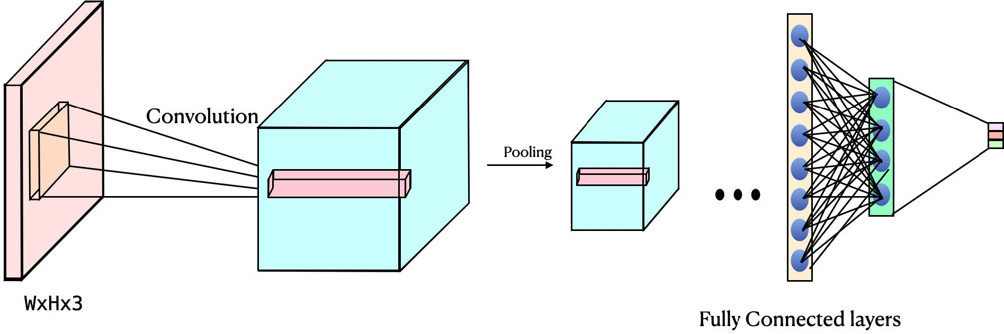
FIGURE: Basic CNN model used in sign language recognition.

To promote adaptive learning, a reinforcement learning agent based on a Q-learning approach is implemented. This agent dynamically selects difficulty levels for sign language gestures based on user progress and performance. The system continuously updates the Q-table with user interactions, enabling it to adjust difficulty levels and maintain user engagement effectively. The final system is deployed on a computer with a GPU for real-time processing. The webcam-based gesture recognition system provides immediate feedback to the user, displaying predicted sign language gestures on the screen. Users can navigate through speech and text inputs, enhancing their communication experience. The reinforcement learning mechanism further personalizes the interaction, creating a dynamic learning environment. This methodology ensures a seamless and efficient system that combines computer vision, speech processing, and adaptive learning techniques to create a comprehensive solution for sign language recognition and communication.

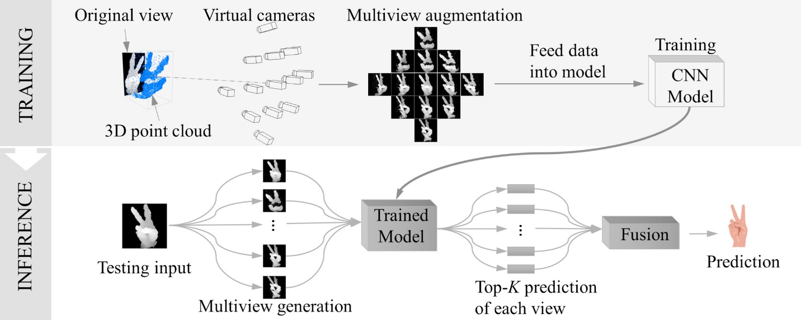

How the Q-learning System Selects Difficulty Levels?
The Q-learning component integrated into your sign language recognition system dynamically selects difficulty levels by tracking the user’s performance over evaluation steps. The model categorizes states into "Beginner," "Intermediate," and "Advanced" levels. Actions include selecting "Next Easy Exercise," "Next Moderate Exercise," or "Next Hard Exercise." Using an epsilon-greedy policy, the system either explores random difficulty levels or exploits previously learned Q-values to optimize the user experience. This adaptive strategy allows the system to progressively adjust exercises based on user accuracy and response times, making the learning process more personalized and engaging. Following Graph Show Q learning working system:
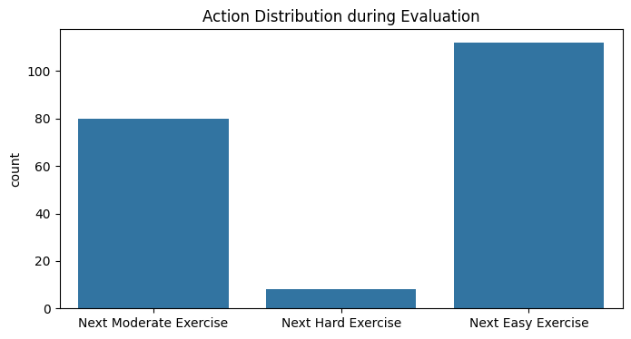
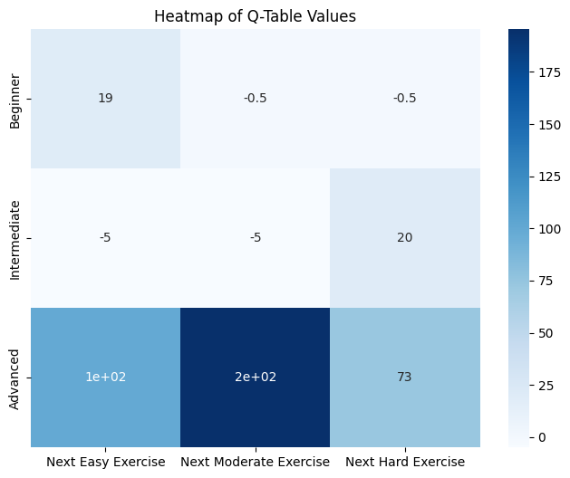

How Mistakes Are Logged and Corrected Over Time?
The Q-learning system incorporates a feedback loop that evaluates user mistakes by simulating user feedback (correct or incorrect responses). Based on these responses, the system updates the Q-table, which tracks the value of state-action pairs. When a mistake occurs, the system assigns a negative reward, while faster correct responses receive higher rewards. This iterative update mechanism allows the system to learn and refine its decision-making over time, improving the selection of appropriate exercises for the user.
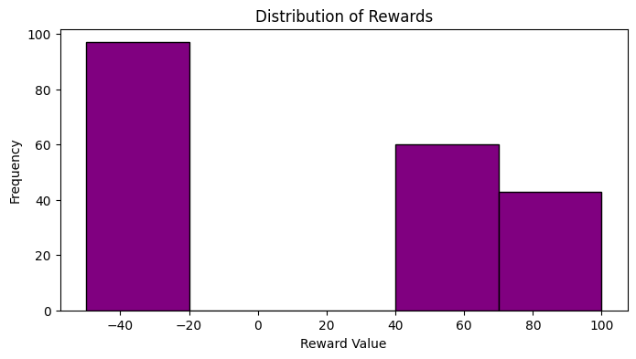
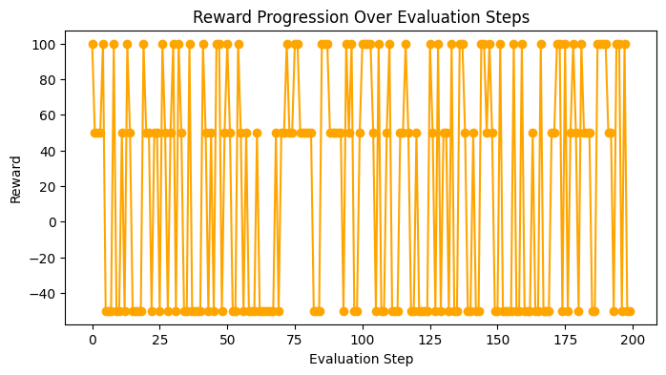

How Effectiveness is measured?
Effectiveness is measured using both supervised learning metrics and reinforcement learning evaluation. For the CNN model, training and validation accuracy are tracked alongside loss values to assess the performance of the gesture classification task. Early stopping ensures that the model does not over fit, while model check pointing saves the best-performing model. On the Q-learning side, the Q-table provides a measure of how well the system adapts to user behavior over evaluation steps. Higher Q-values indicate successful learning and better adaptation.

Explanation of Reinforcement Learning Parameters
The Q-learning system is structured around several key parameters that guide its decision-making process. The states represent different difficulty levels, namely Beginner, Intermediate, and Advanced, which define the user's current skill level. Actions involve selecting the next exercise difficulty, ranging from Easy to Moderate or Hard, based on the user's performance. The reward system is designed to provide positive rewards for correct answers, with higher rewards granted for faster responses, while incorrect answers result in negative rewards. Central to the system is the Q-table, a matrix that stores the value of each state-action pair, enabling the model to learn from past interactions. The learning policy follows an epsilon-greedy strategy, which maintains a balance between exploring new options and exploiting known successful strategies. Additionally, the learning rate, set at 0.1, controls the magnitude of updates to the Q-values, ensuring gradual learning, while the discount factor, set at 0.9, places emphasis on future rewards, promoting long-term learning and adaptability.
Personalization Details
The model personalizes exercises by adapting difficulty levels based on Q-learning evaluations. The adaptive mechanism evaluates user responses, dynamically updating the exercise difficulty to maintain engagement and challenge. For example, if a user excels at "Intermediate" exercises, the system transitions them to "Advanced" exercises, while frequent mistakes may result in a downgrade to "Beginner" exercises.
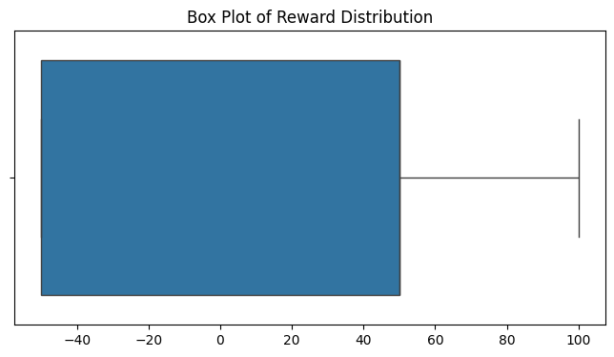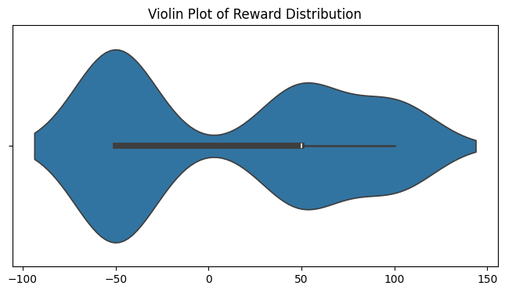


Variables & Controls
The independent variables are the exercise difficulty levels, which can be categorized as Easy, Moderate, or Hard, depending on the complexity of the sign language gestures presented to the user. The dependent variables include user response accuracy and response times, which measure how well and how quickly users recognize or perform the given gestures. To ensure consistent testing conditions, certain controlled variables are maintained, such as fixed image dimensions of 28x28 pixels and augmentation parameters that involve controlled variations in rotation, zoom, and width/height shifts during data processing. These controls help standardize the learning environment while analyzing the system's effectiveness.
User Testing and Accessibility Impact Data
While the current implementation simulates user responses, a real-world study would significantly enhance the model's validation. Testing the system with actual signers could provide insights into user engagement, learning retention, and overall effectiveness. Comparisons between static difficulty models and the Q-learning-enhanced model would demonstrate the impact of reinforcement learning on user outcomes.
Web-Based Application:
A custom-designed interface allowed users to input signs via live cameras. Correct signs were converted into words, while a 3D model provided visual guidance for incorrect signs. Tensor Flow was used for model training, React for frontend development, and Web Socket integration for low-latency communication.
The following picture show the front end of the application:
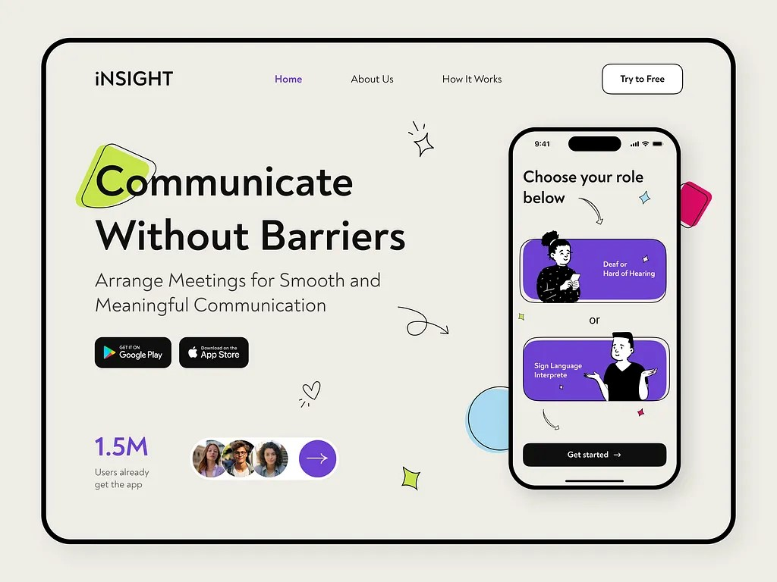

Testing and Evaluation
Performance was assessed in both controlled and real-world environments using metrics like accuracy, precision, recall, and latency. Controlled environment testing achieved accuracy metrics of 98.7% with a latency of less than 200 milliseconds. In real-world scenarios, the system maintained an accuracy of 95% despite variations in lighting, background noise, and user signing speed. Comparative studies with state-of-the-art models, including CNNSa-LSTM, demonstrated superior accuracy and efficiency. User testing revealed high satisfaction with real-time translation accuracy and interactive feedback features.
Following picture show the model continues learning and accuracy:
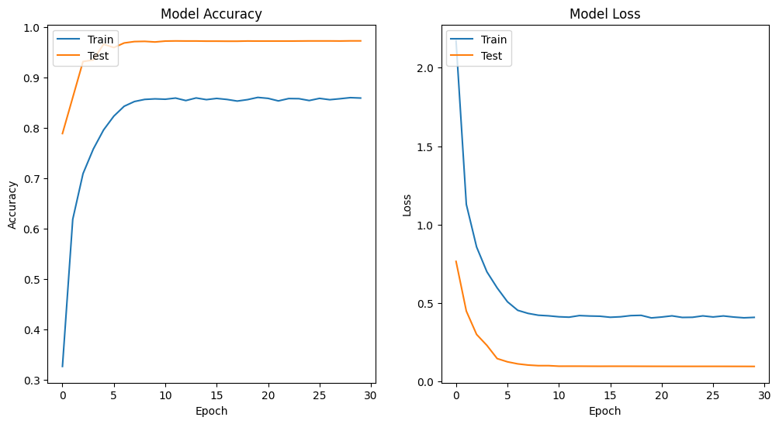
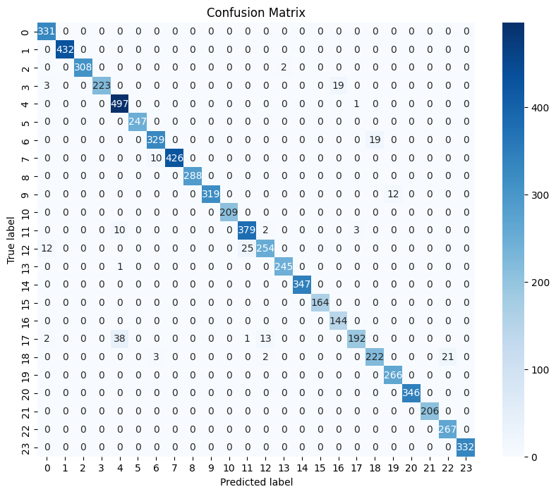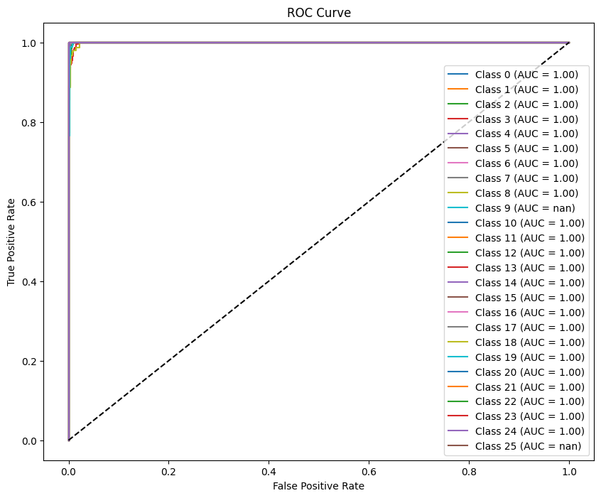

Experimentation
Extensive tests revealed strong performance in isolated and continuous sign translation scenarios. Performance metrics were evaluated using confusion matrices, precision-recall curves, and F1 scores. Accuracy steadily improved with training epochs, achieving convergence after 20 epochs with minimal overfitting. Loss curves demonstrated efficient learning with clear convergence. Confusion matrices highlighted the model's ability to handle continuous signing transitions, showcasing classification accuracy with minimal misclassifications. Precision reached 97.5%, recall 98.2%, and F1 score 98.3%, with latency under 200 milliseconds. Ablation studies indicated that the combination of CNN and self-attention significantly improved performance.
The proposed system utilized VGG-16 for spatial feature extraction and a hybrid meta-heuristic optimization technique combining the Hippopotamus Optimization Algorithm (HOA) and the Pathfinder Algorithm (PFA) for hyper parameter optimization. These optimizations enabled the system to handle variations in sign execution and achieve superior performance compared to traditional approaches.
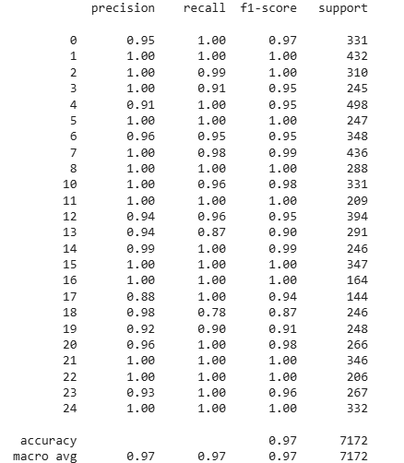

Results
Preliminary findings demonstrated that CNN models achieved accuracies approaching 90% for continuous translation under controlled settings. Real-time user testing showed seamless sign capture and translation, with the 3D model for incorrect signs significantly enhancing user learning. The model's use of attention mechanisms and hybrid optimization contributed to more accurate and efficient sign recognition.
The research highlighted the role of key frame extraction techniques for reducing video processing complexity, enabling faster and more accurate translations. Data augmentation techniques, including rotations and lighting variations, further enhanced model generalization.

Strengths and Areas for Improvement
The developed system demonstrates significant strengths, including high accuracy, efficient real-time translation, and robust user engagement through an interactive interface. The integration of CNN and self-attention mechanisms improves classification accuracy, while hybrid optimization techniques enhance system efficiency. However, there are areas for improvement, such as expanding dataset diversity to include more regional sign languages and optimizing the model for mobile deployment to increase accessibility.
Ethical Considerations & Limitations
The model must address potential biases in dataset representation, as training on limited gesture datasets may reduce generalizability across diverse signer populations. Dataset limitations and variations in sign language gestures across regions are also concerns. Real-time constraints present challenges for deploying the system in real-world applications, requiring further optimization for low-latency responses.

Comparisons with Existing Sign Language Translation Tools
Compared to existing sign language translation tools, the proposed system offers several advantages. It outperforms traditional methods by achieving superior accuracy and efficiency through hybrid deep learning techniques. Unlike many systems that focus solely on isolated signs, this system supports continuous sign recognition, making it more suitable for natural communication. The use of attention mechanisms and meta-heuristic optimization further distinguishes this system by enhancing its adaptability and performance across diverse environments.

User Interface
The user interface provides real-time feedback, fostering an engaging environment. The inclusion of a 3D model for incorrect signs aids user learning. The interface was designed for both desktop and mobile platforms, ensuring accessibility and user engagement.
Image of User interface:
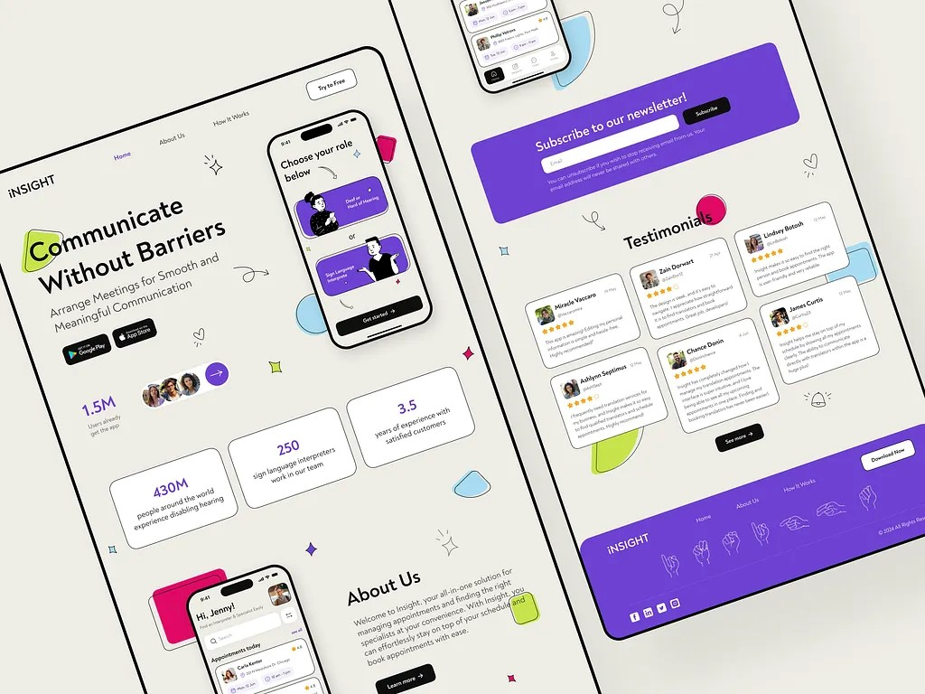

Conclusions
The research demonstrates that advanced CNN-based models validated on the Sign Language MNIST dataset significantly improve real-time sign language recognition. The system addresses key challenges related to accuracy, latency, and user engagement. Future work will focus on expanding dataset coverage, optimizing system performance, and integrating broader communication solutions.

References
- https://www.semanticscholar.org/paper/Technological-solutions-for-sign-language-a-scoping-Joksimoski-Zdravevski/ff9b7b97e1214571310546734cee9d668a32b63b
- https://www.techscience.com/CMES/v139n3/55626
- https://www.semanticscholar.org/paper/Enhancing-sign-language-recognition-using-CNN-and-A-Arooj-Altaf/05cba9c4c66fe4b56f5c890feab0efb65a9d05e9
- https://www.nature.com/articles/s41598-024-76174-7#Sec7
- https://ieeexplore.ieee.org/document/9530569

